Day 5 – 30/05/2025

Q1. Create a directory “LinuxPractice”  
Ans. mkdir LinuxPractice

Q2. Change to the new directory.  
Ans. cd LinuxPractice

Q3. Create a file name TestFile1.txt and add the content to it.  
Ans. echo “Hello World!!” > TestFile1.txt

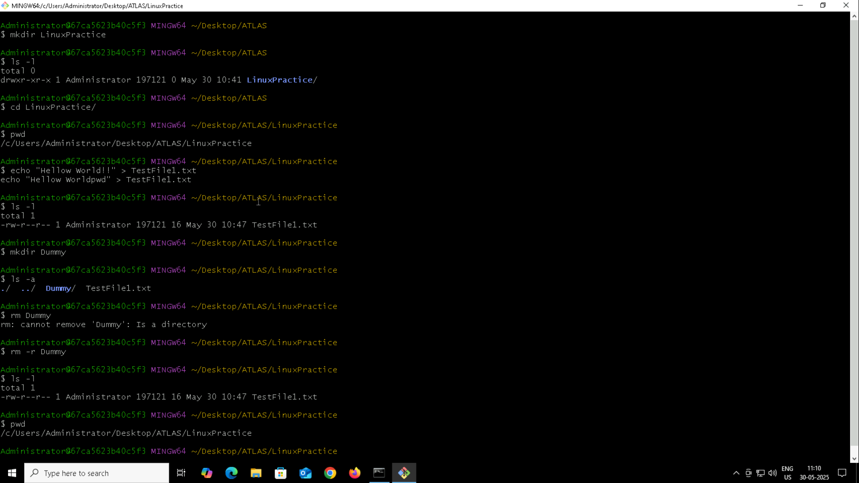

Q4. Create a folder named Dummy and try to delete it.  
Ans. > mkdir Dummy  
 > rm -r Dummy

Q5. Check the working directory.  
Ans. pwd

Q6. How do you check all the files and directories in the directory you are in?  
Ans. ls -a

Q7. Create five files TestFile2.txt, TestFile3.txt, TestFile4.txt and TestFile5.txt.   
Ans. touch TestFile2.txt TestFile3.txt TestFile4.txt TestFile5.txt

Q8. Move all the files to a new directory  
Ans. > mv TestFile1.txt TestFiles  
 > mv \*.txt TestFiles

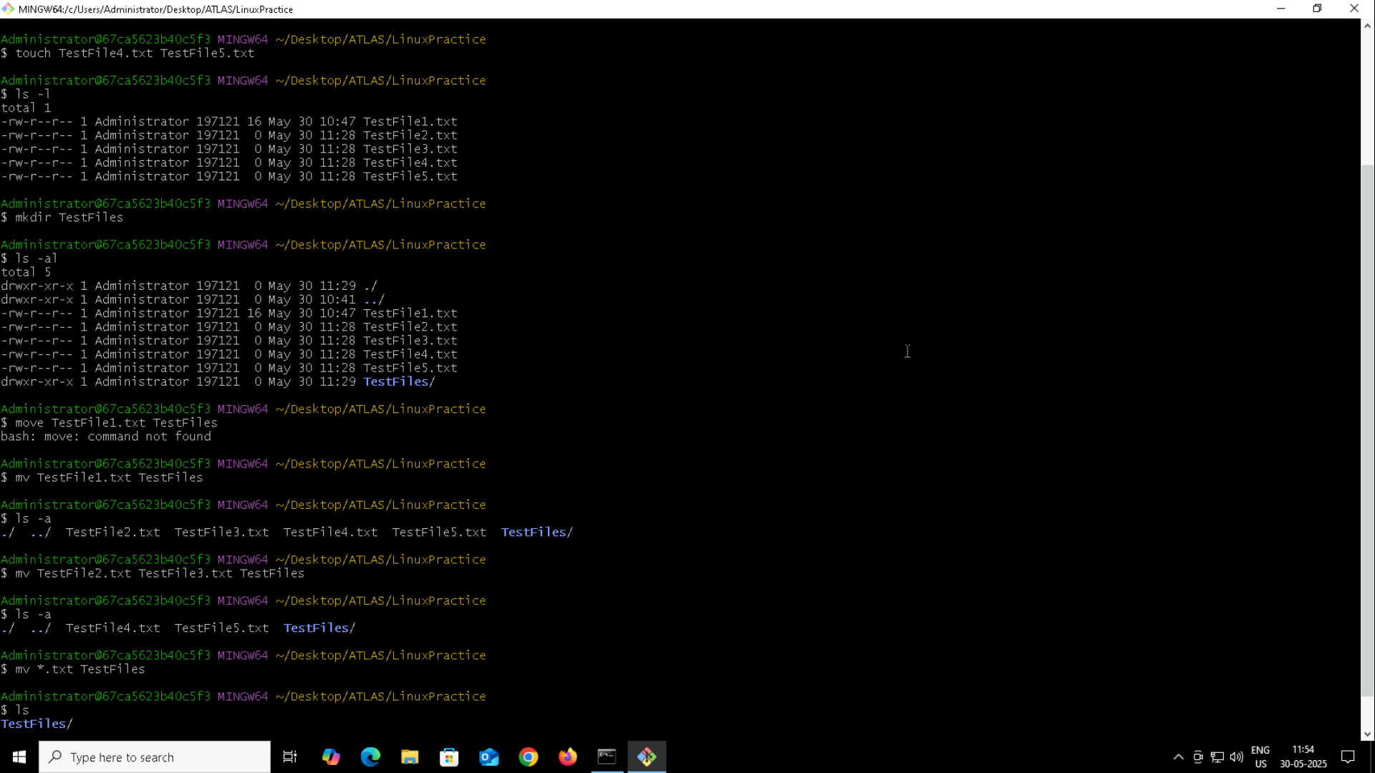

Q9. Move all files from Dir 2 to Dir 3.  
Ans. > mkdir TextFiles  
 > mv TestFiles/\* TextFiles/

Q10. Can you plz show me the diff between rm and rmdir commands with screenshots?  
Ans. rm is used to remove files rmdir is used to remove directories.

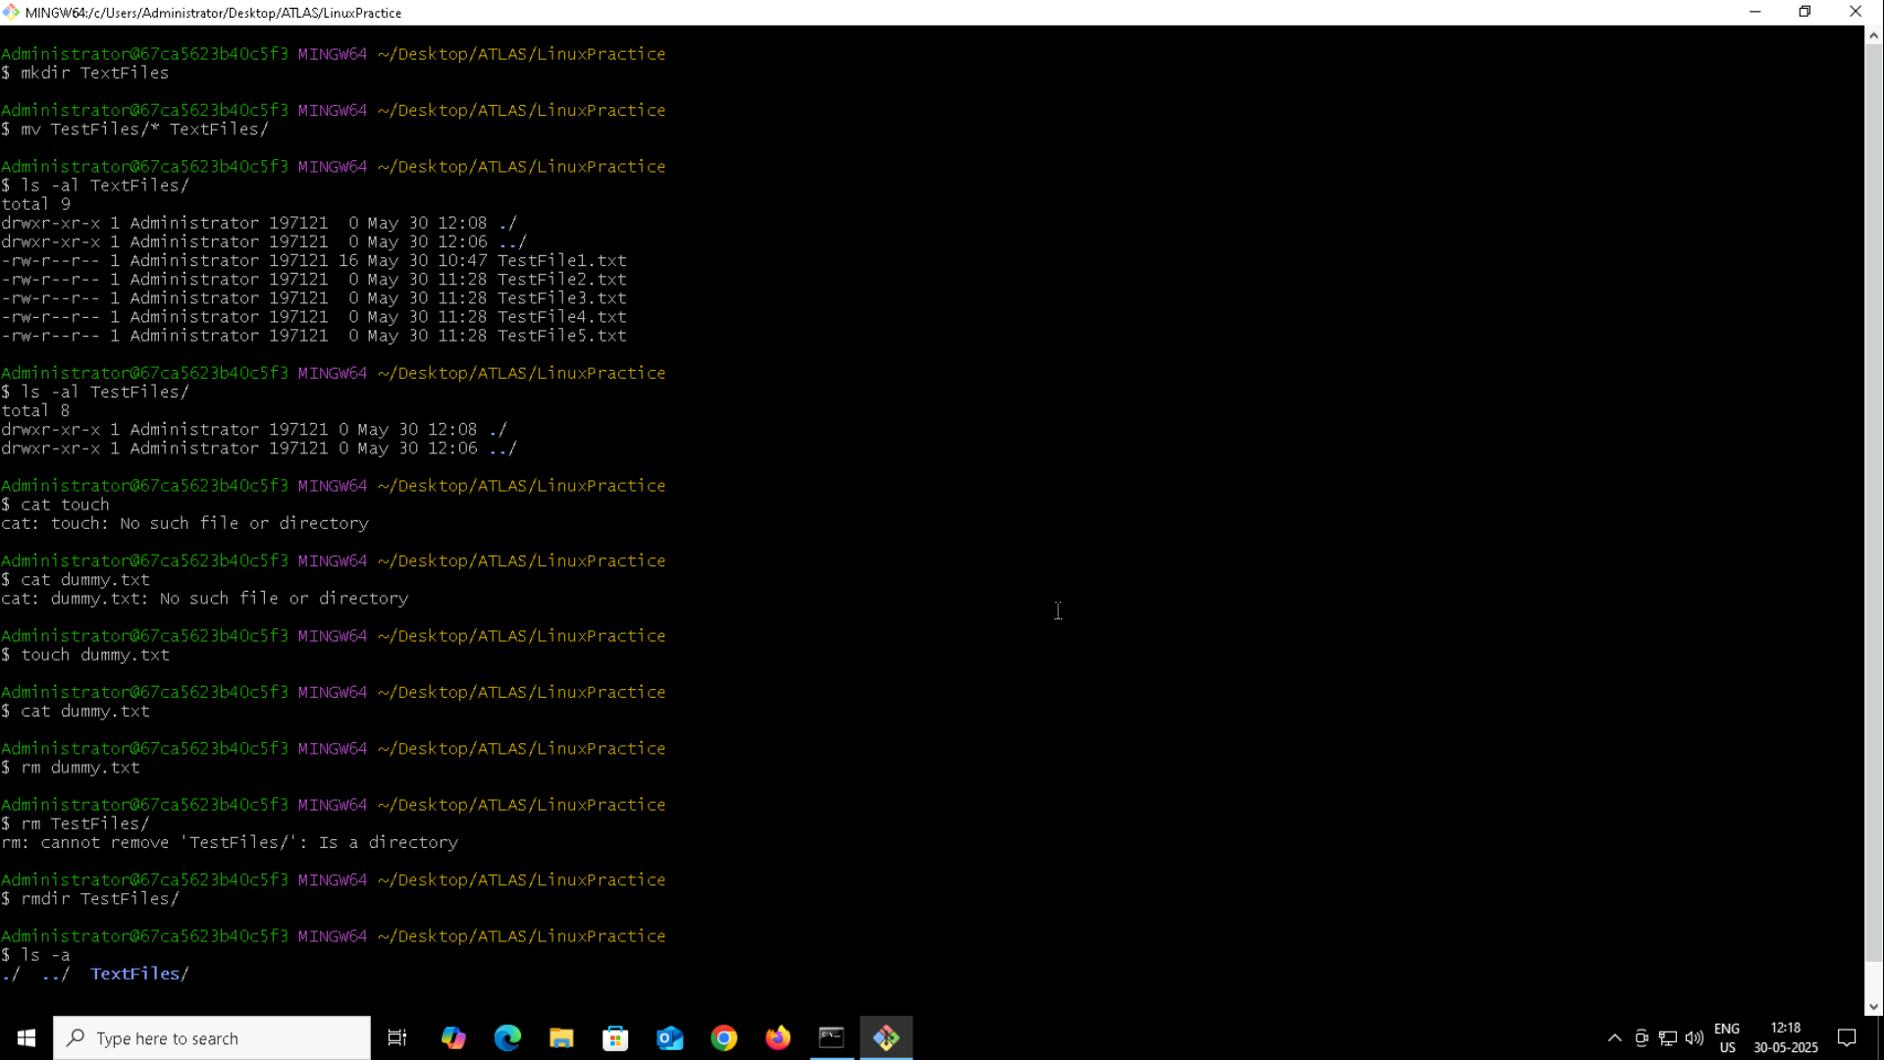

Q11. Now use specifically cat command to create a file and add the dummy text of 2 to 3 paragraphs.  
Ans. cat > Lipsum.txt

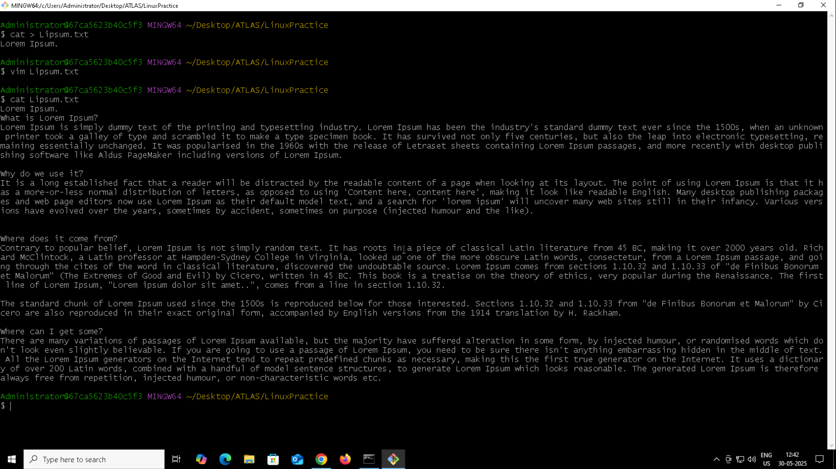

Q12. How to get only the top part of your file.  
Ans. head Lipsum.txt

Q13. How to get only the last part of your file.  
Ans. tail Lipsum.txt 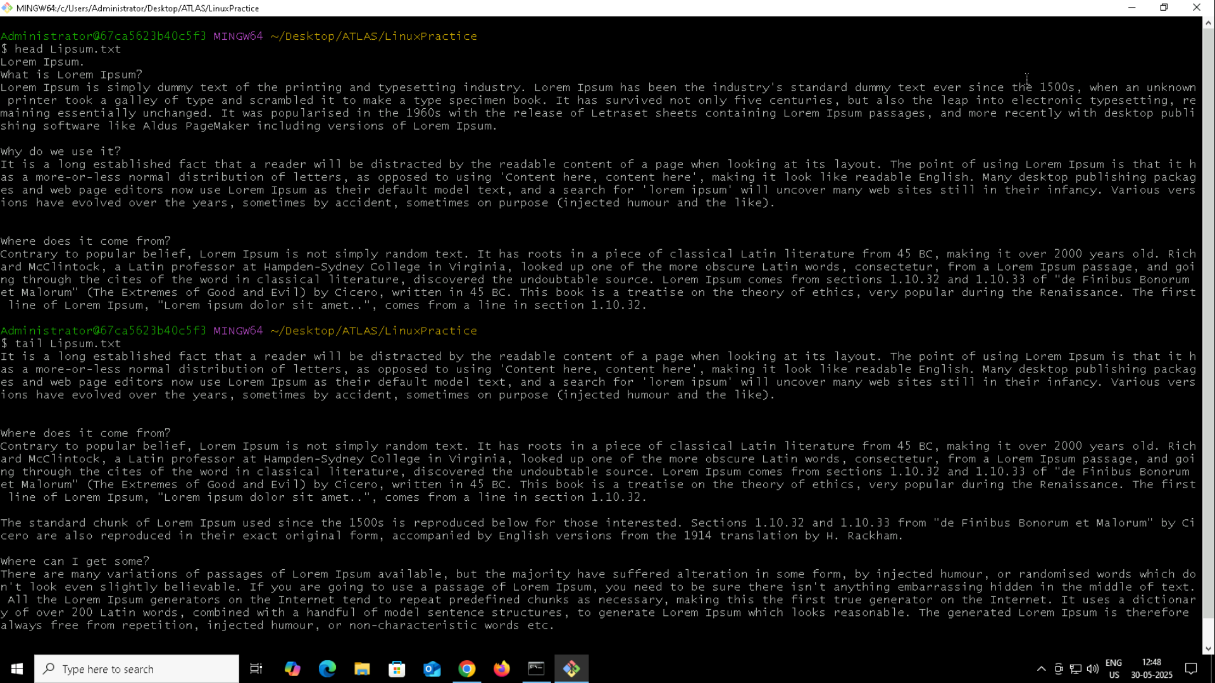

Q14. Add dummy text of 5 to 6 pages in to the same file and show the file in page by page.   
Ans. less Lipsum.txt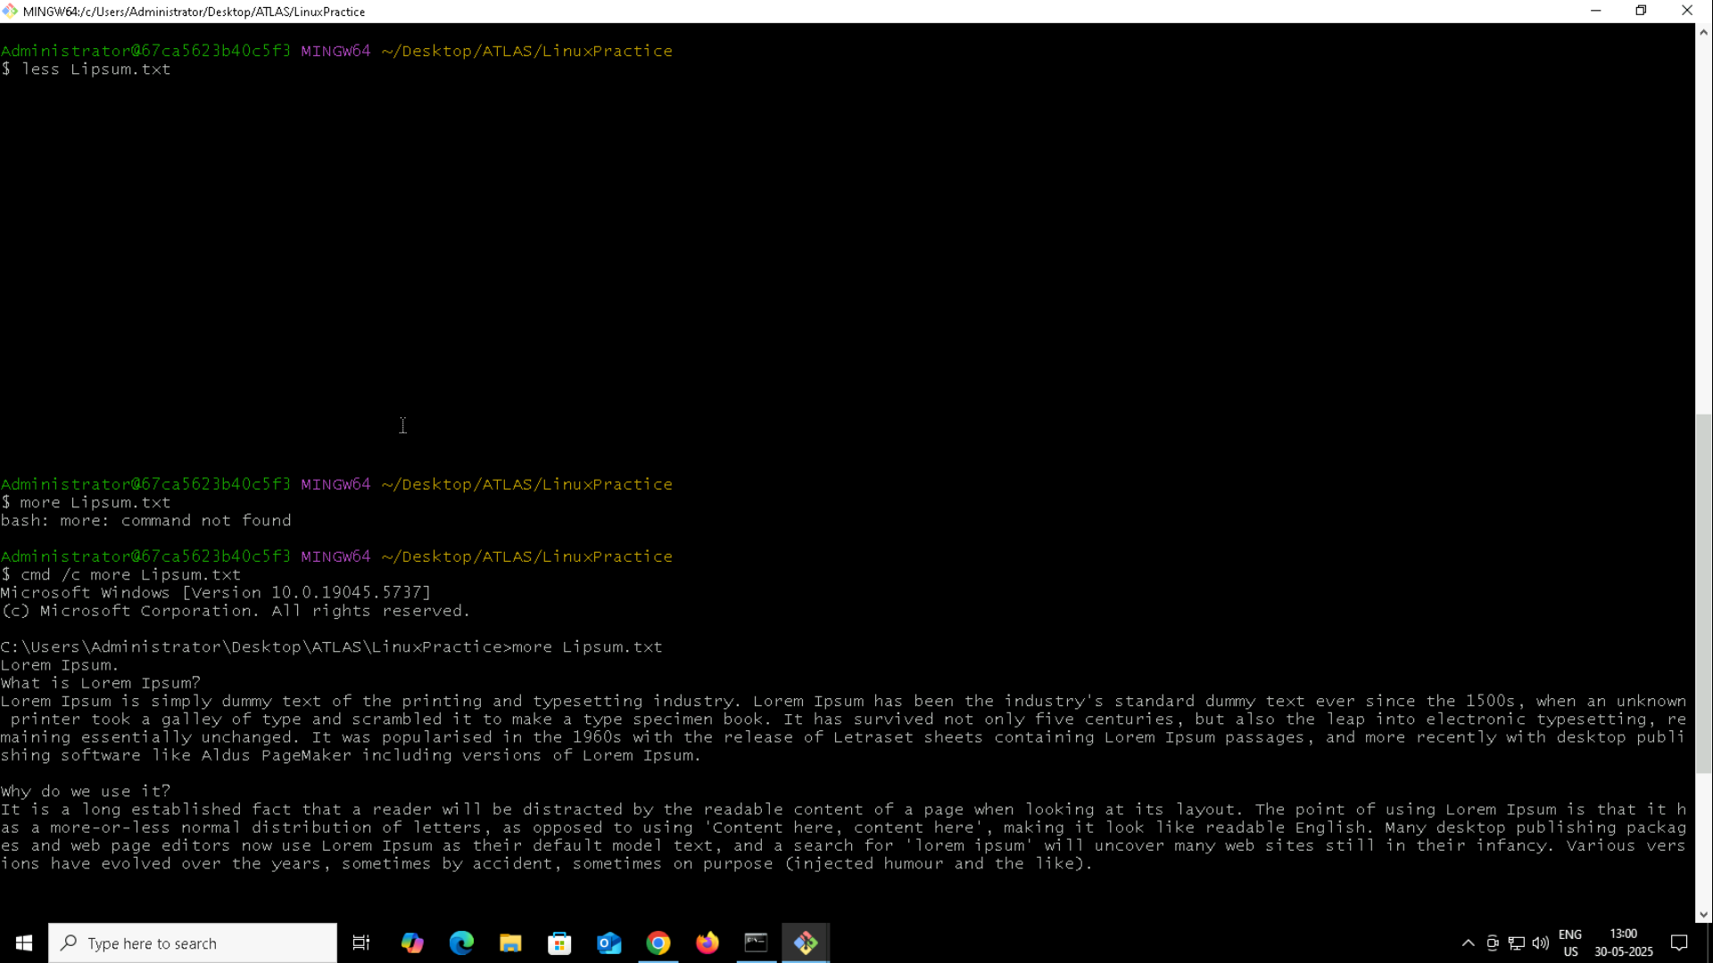

Q15. Use more command on the above file and find out the diff between less and more commands.  
Ans. more Lipsum.txt

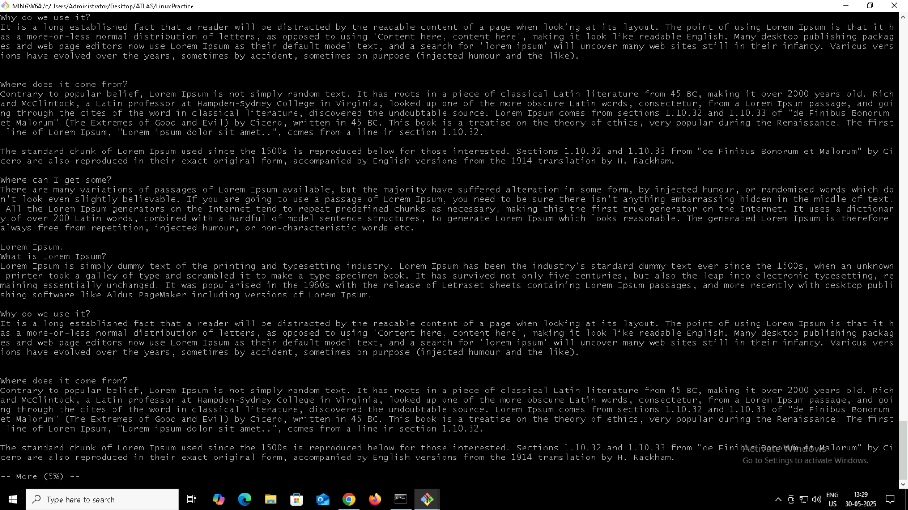

Q16. Can you use echo command with -e and see the diff.  
Ans. Without -e echo will not consider newline(\n) as part of the string and displays. Using -e breaks the string and displays string after \n in new line. 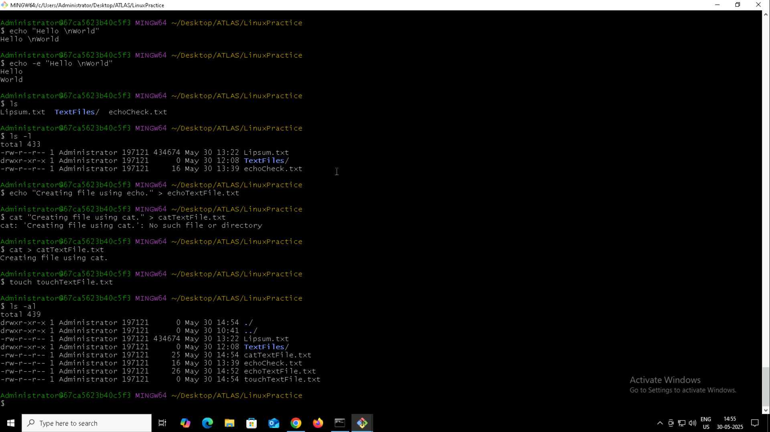

Q17. What is diff between ls and ls -l command?  
Ans. ls lists the files available on the working directory. Ls -l displays file details along the files.

Q18. Create a file using touch, cat and echo command and differentiate them.  
Ans. touch – just creates the file without content.  
 cat – Used to read the content of the file. Creates file along the content.   
 echo – Used to write the content to the file. Creates the file along the content.

Q19. Can you guys try to display the calendar by using a command.  
Ans. Yes, cal.

Q20. Can you go back to 1 directory .. at a time whats the command?  
Ans. Yes, cd ..

Q21. How to know whose user u are working on?  
Ans. whoami

Q22. Try to find out who is peeping into your system.  
Ans. who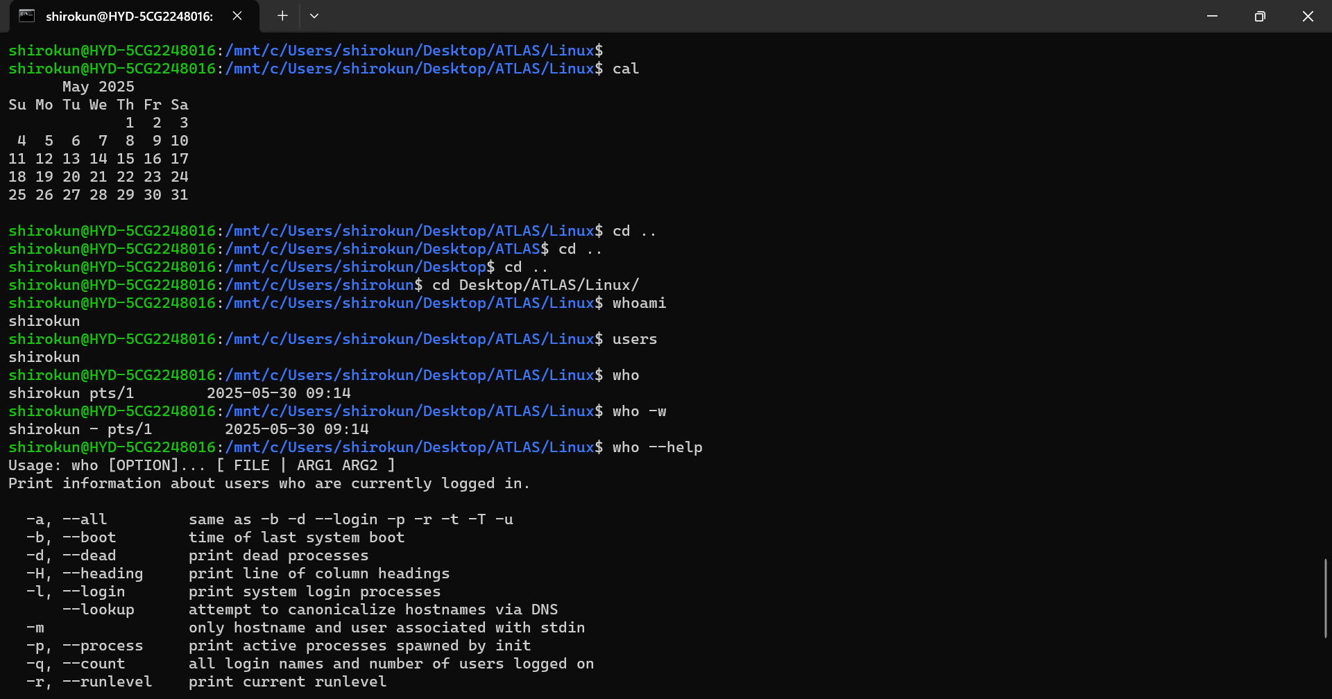

Q23. Can you guys try to check how much disk space is consumed.  
Ans. df -h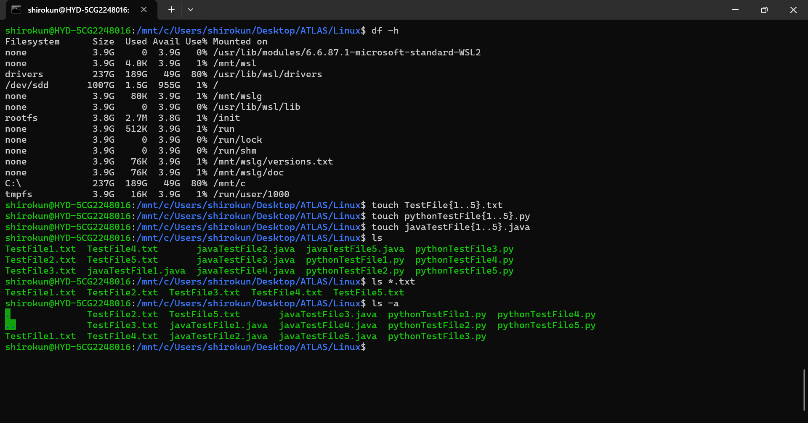

Q25. Find the list of all files ending with .txt.  
Ans. ls \*.txt

Q26. How to check all the hidden files in Linux?  
Ans. ls -a

Q27. What is the difference between . and .. in linux?  
Ans. In linux . represents current working directory and .. represents parent directory of current working directory.

Q28. Create a file using VIM edior.  
Ans. vi sampleCfile.c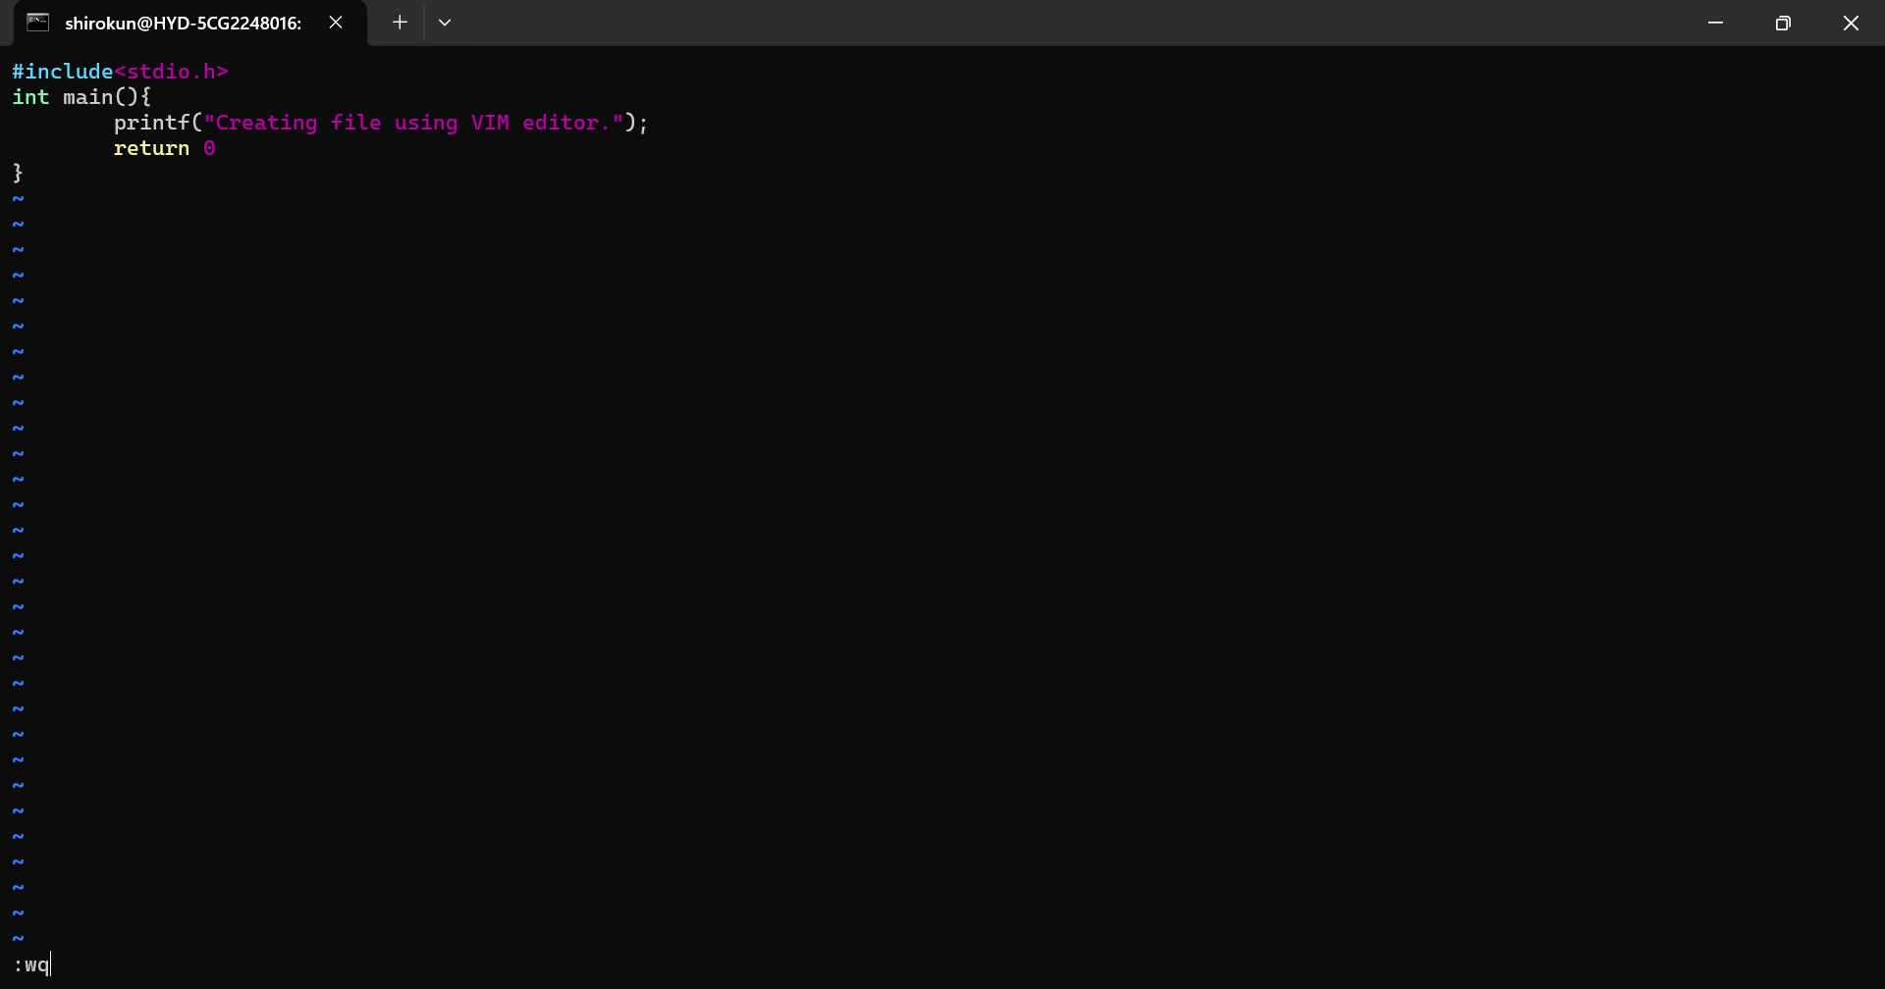

Q29. How to find the no of words in the file?  
Ans. wc sampleCFile.c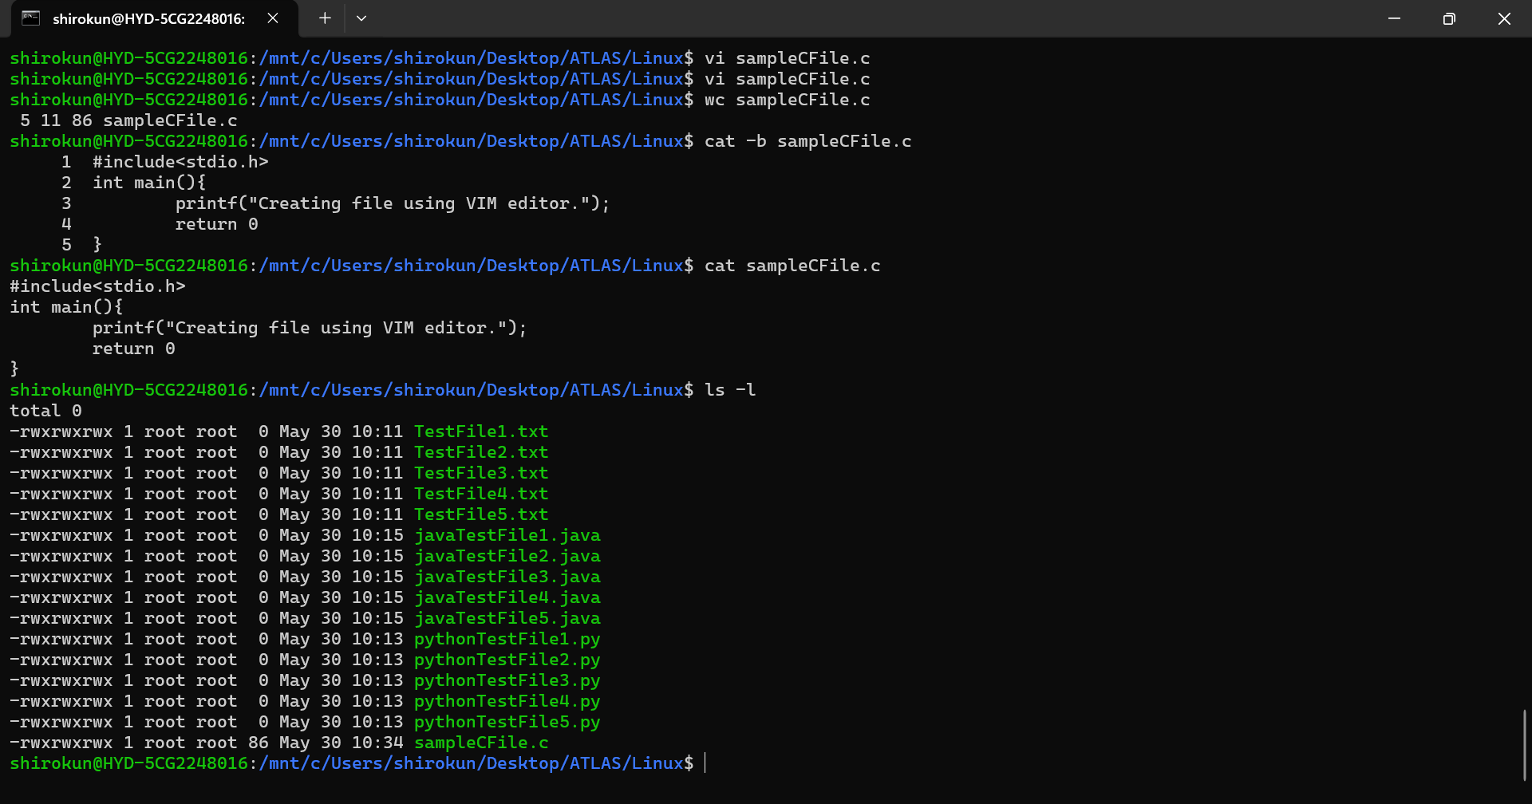

Q30. What is the use of cat -b myfilename.txt command?  
Ans. It provides the line numbers along the con  
tent of the file.

Q31. Can I use the wc with 2 or more files?  
Ans. Yes. wc TestFile1.txt sampleCFile.c

Q32. How to copy content of one file to another file?  
Ans. cp sampleCFile.txt sampleCFile.c

Q33. Rename my file with MYFILENEW can i do that if so how?  
Ans. mv sampleCFile.c testFile.c

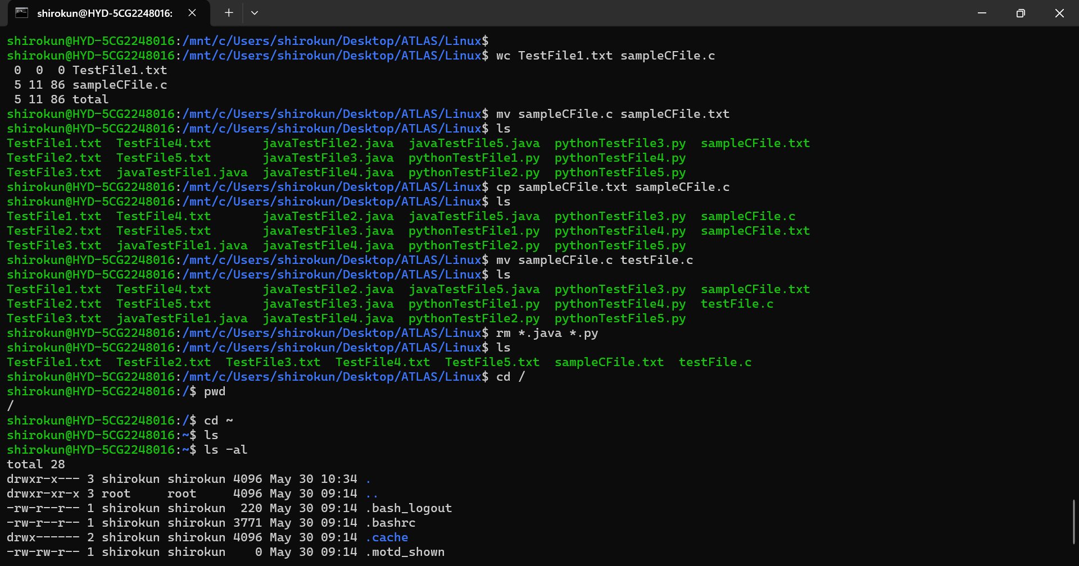

Q34. Can i remove or delete multiple files in linux..? How?  
Ans. Yes. rm \*.java \*.py

Q35. In directory / slash is root … can you try cd / what is it doing?  
Ans. It went to root directoty.

Q36. What is the way go go to home directory?  
Ans. cd ~

Q37. If i want to move to different users home directory.  
Ans. cd ~shiro

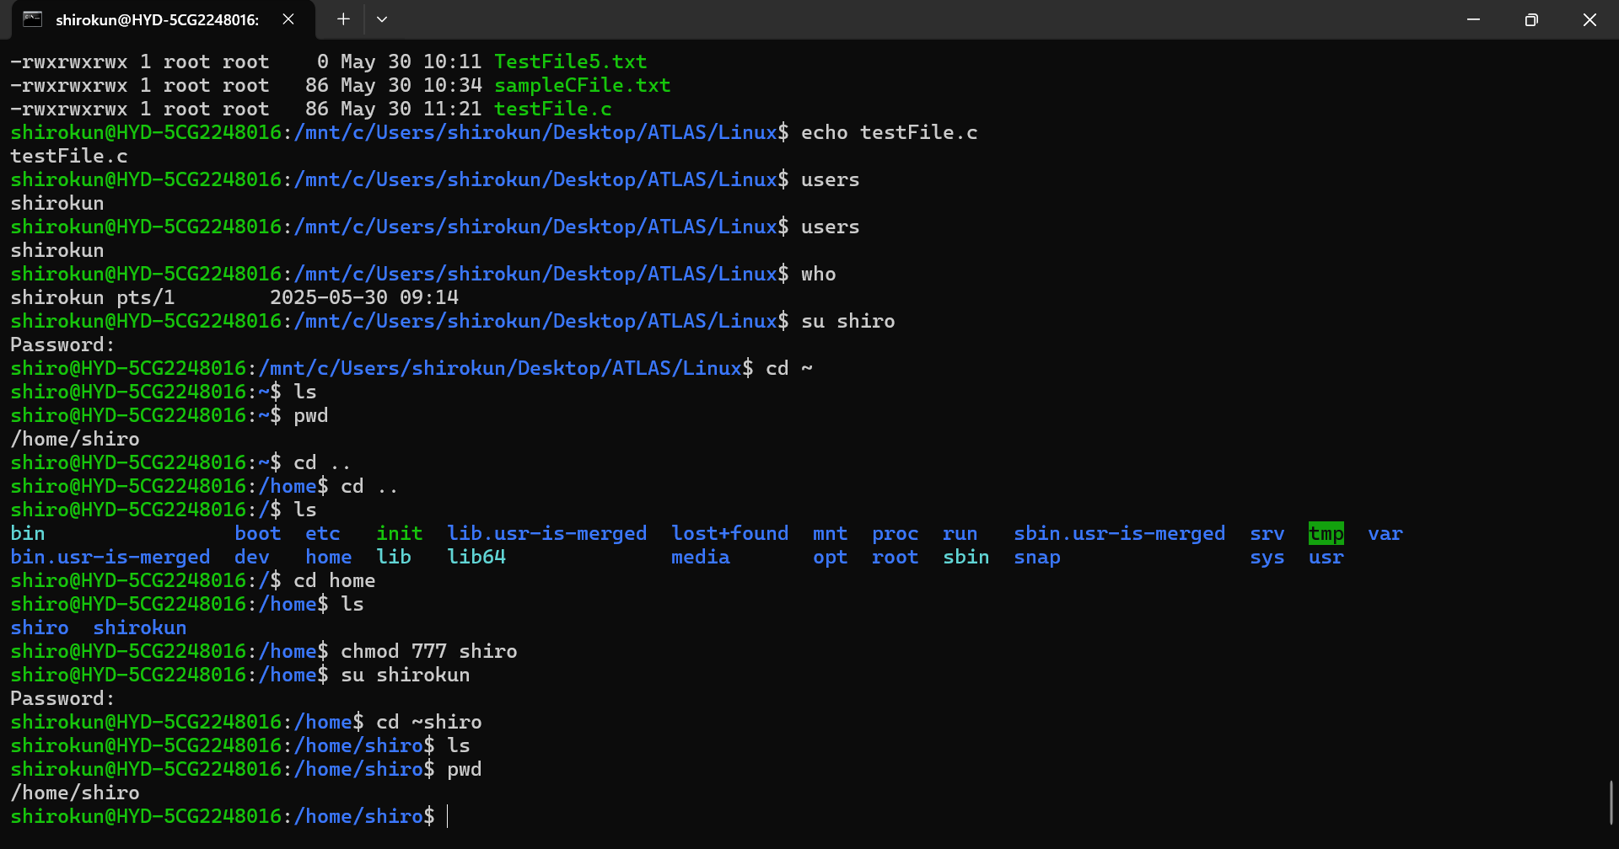

Q38. Chmod  
Ans. chmod 777 shiro